



HOW TO GUIDE:
HOSTING CONTROLLER

- TO EDIT A MAILBOX:

- Click on “Dashboards”:

After which you will be directed to the following settings:
- Change the Password of the Mailbox
- Mailbox Stats: When clicking on the “Refresh” button, the Mailbox Usage Size will be show.
- General Properties: To edit Display Name.
- Advanced Properties: To edit Mailbox Size.
- Email Addresses: To add Alias.
- Send on Behalf Permissions: The Send on Behalf Permission is another example of a delegate Access Permission which can be granted to a user by another user. With Send on Behalf Permissions, a user may send emails that are marked as, "on behalf of" another user.
- Full Access Permissions: Allows the delegate to open the Mailbox and
view / add / remove the contents of the Mailbox.
- Send as Permissions: The Send as Permission is an example of a delegate access Permission that can be granted to a user by an administrator.
- Forwarding: Email forwarding allows the delegate to set up a Mailbox in order to forward email messages which are sent to one user's Mailbox, to another user's Mailbox, in or outside of your organization.

1.1 Mailbox Dashboard:

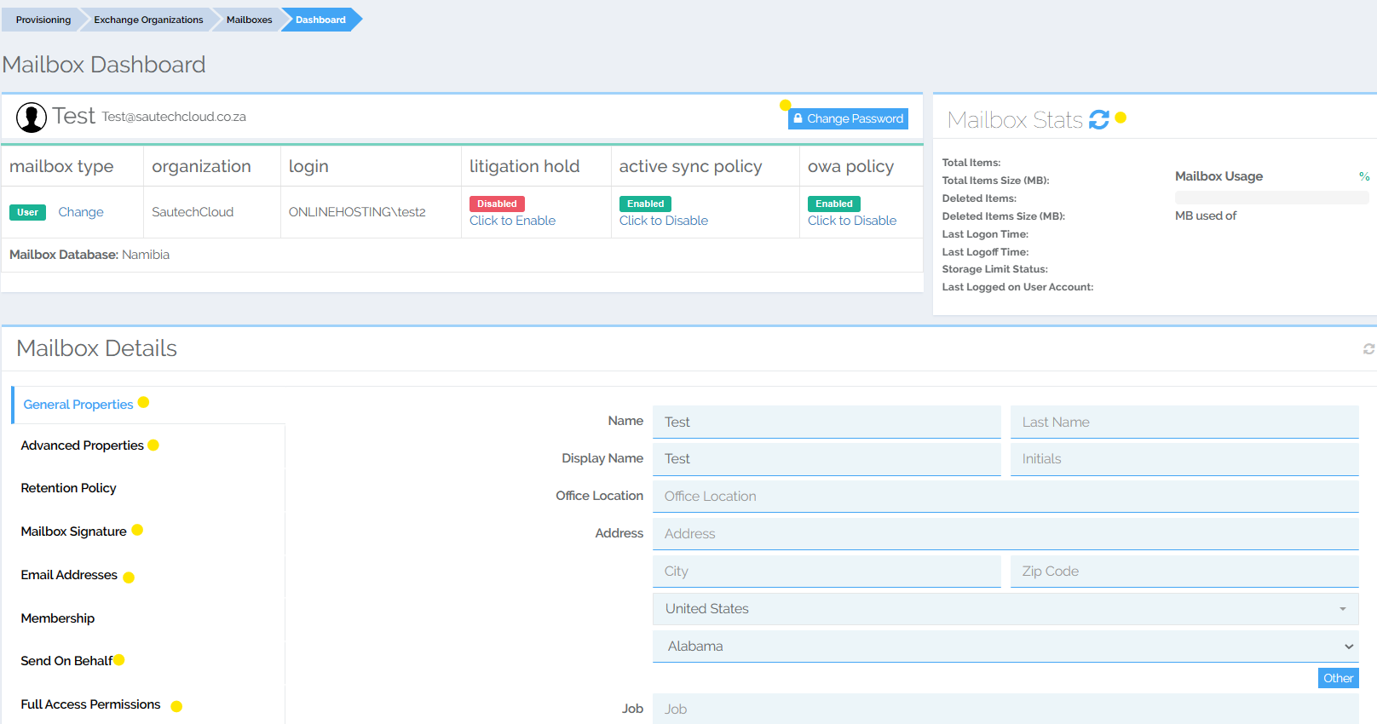
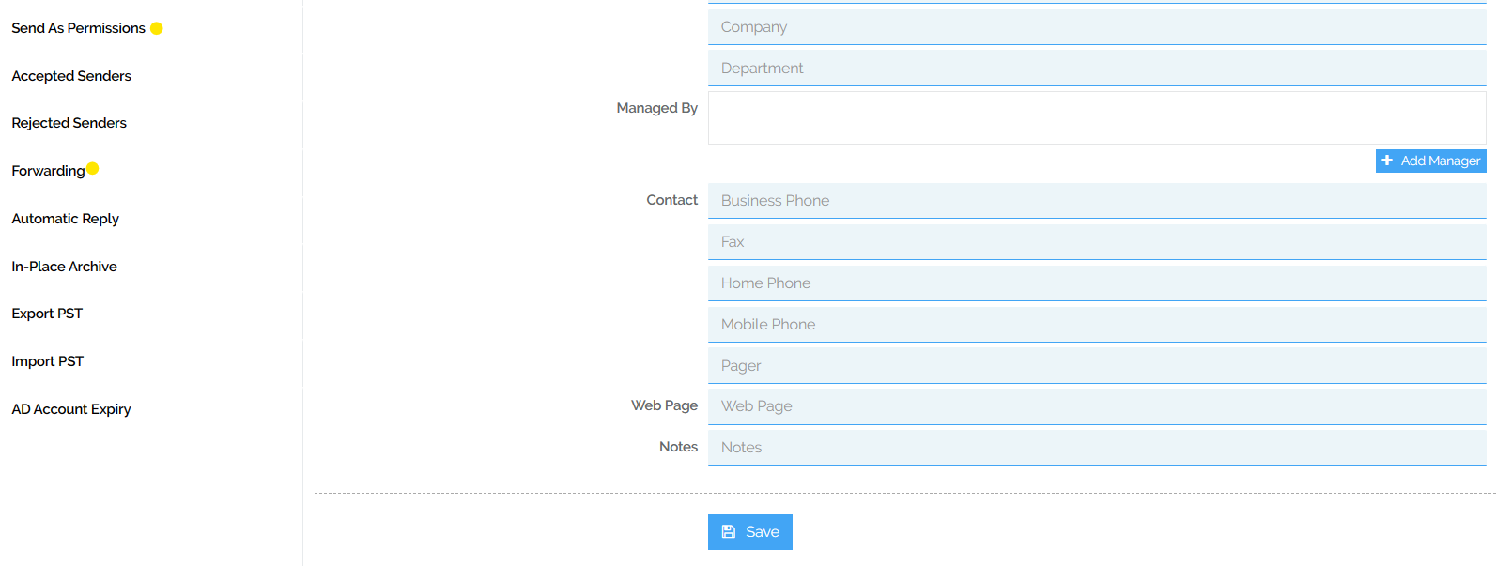

1.2 Advanced Properties:

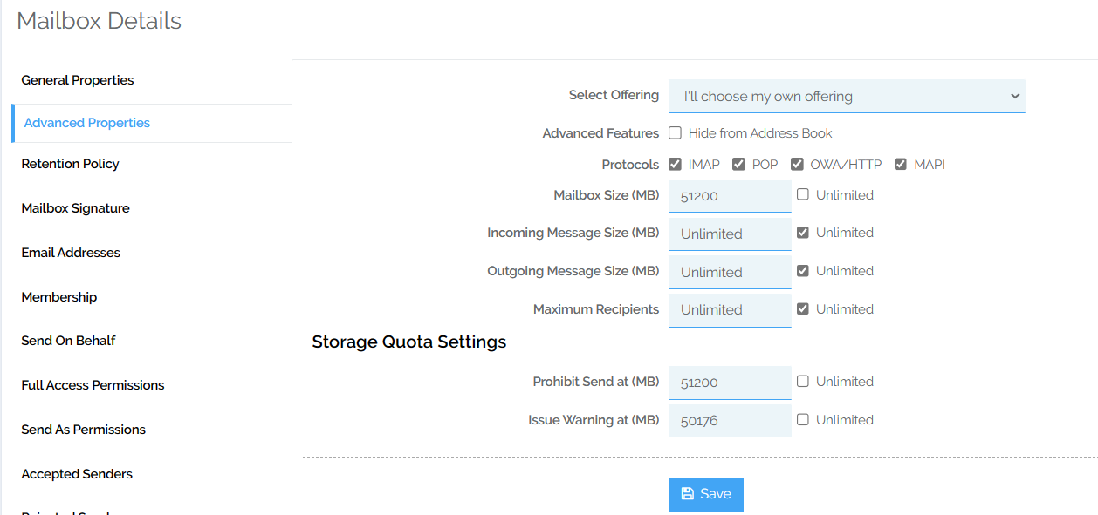

1.3 Email Addresses:

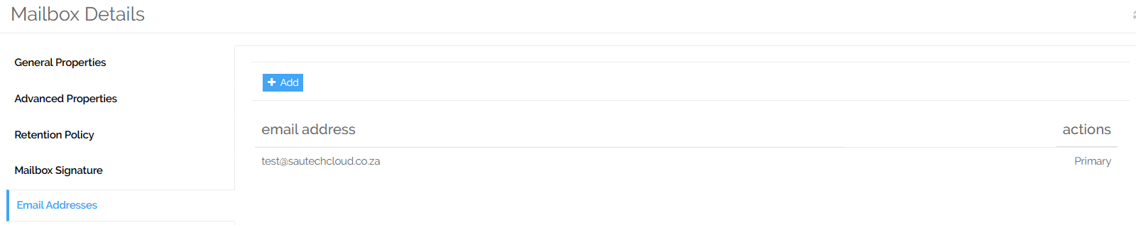

1.4 Send on Behalf:

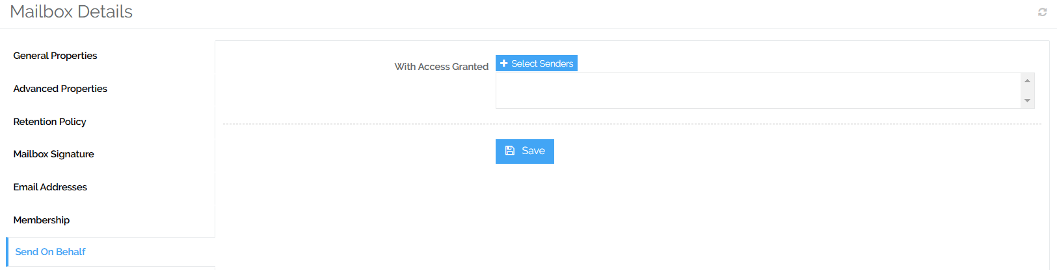

1.5 Full Access Permissions:

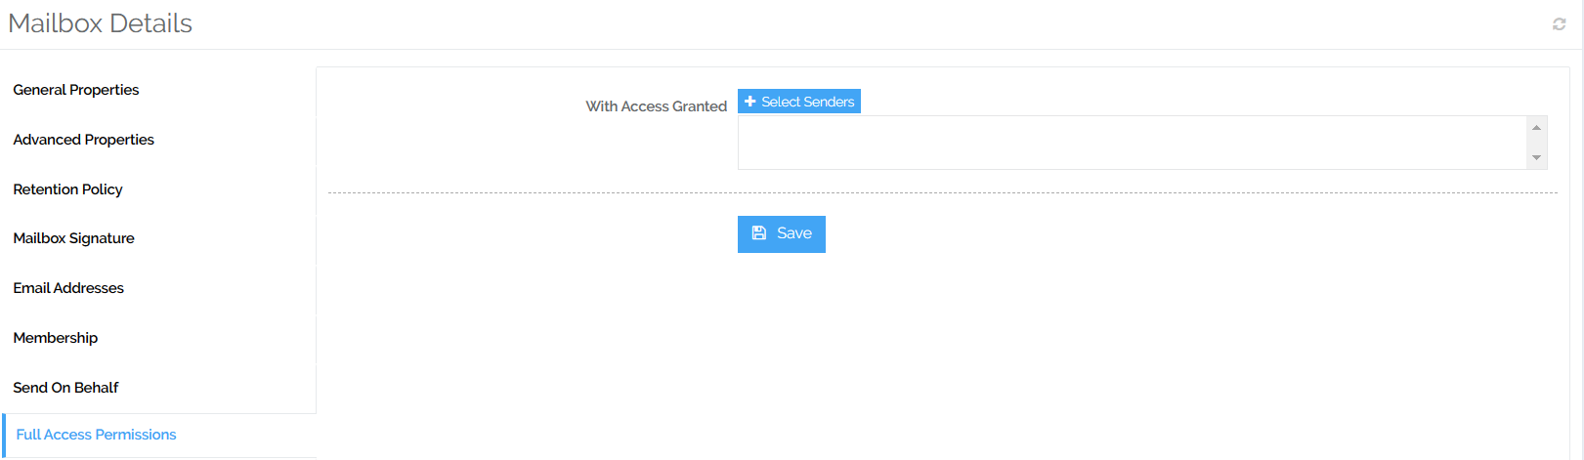

1.6 Send as Permissions:

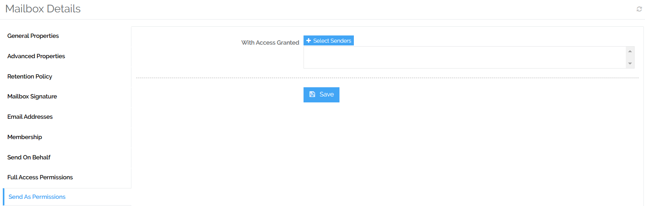

1.7 Forwarding:

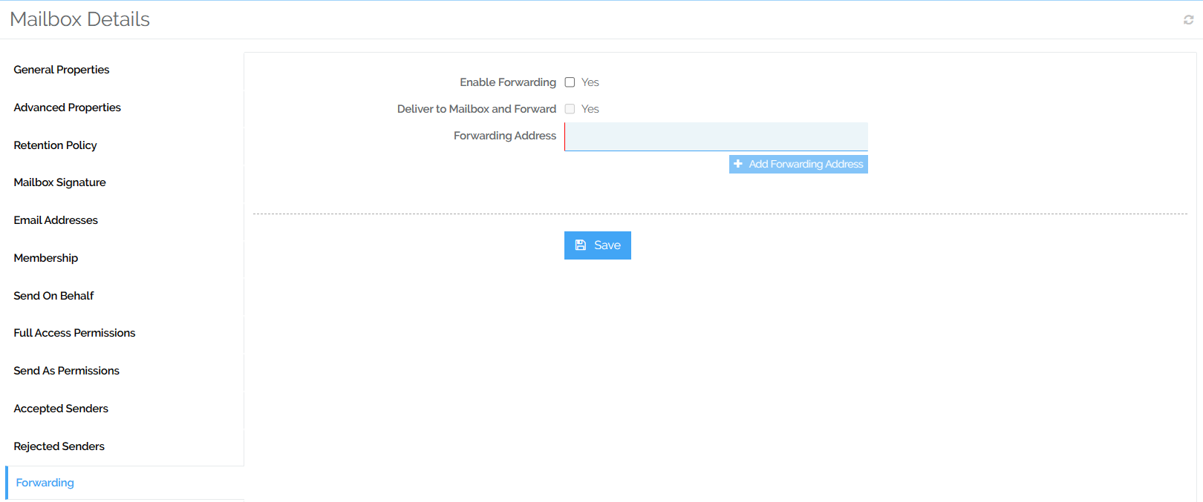

- TO DELETE A MAILBOX:

- The Mailbox has to be disabled first, before deleting.
- A Backup has been made, if required.

2.1 Click on “Disable”:

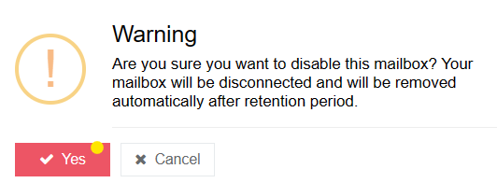

- Ensure Mailbox does not stay disabled if not deleting the Mailbox.

2.2 Click on “Delete”:

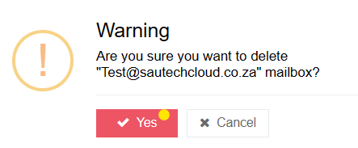
- TO CREATE DISTRIBUTION LISTS:

3.1 Click on “Distribution Lists”:

3.2 Click on “Create Distribution Group”:

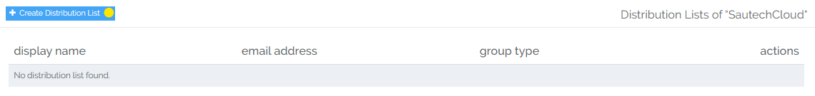

Complete the following Information:
- Display Name
- Email Address
- Tick the “Senders” inside and outside of “My Organization Box”:

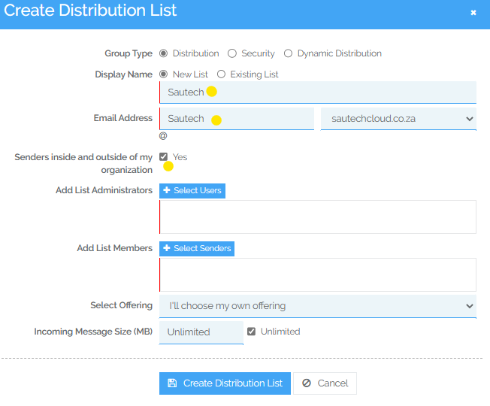

3.3 Add “List Administrator” – Click on “Select Users”:

- Tick the user you choose as Administrator of the Group (Multiple users can be added).
- Click on “Add”
- Click on “Select Objects”:

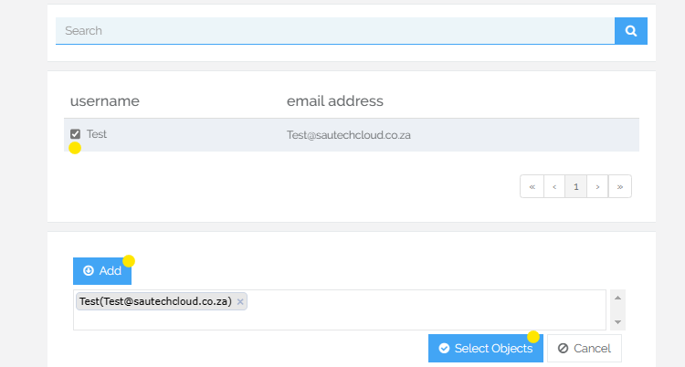

3.4 Add “List Members” – Click on “Select Senders”:

- Tick the members you choose to add
- Click on “Add”
- Click on “Select Objects”:

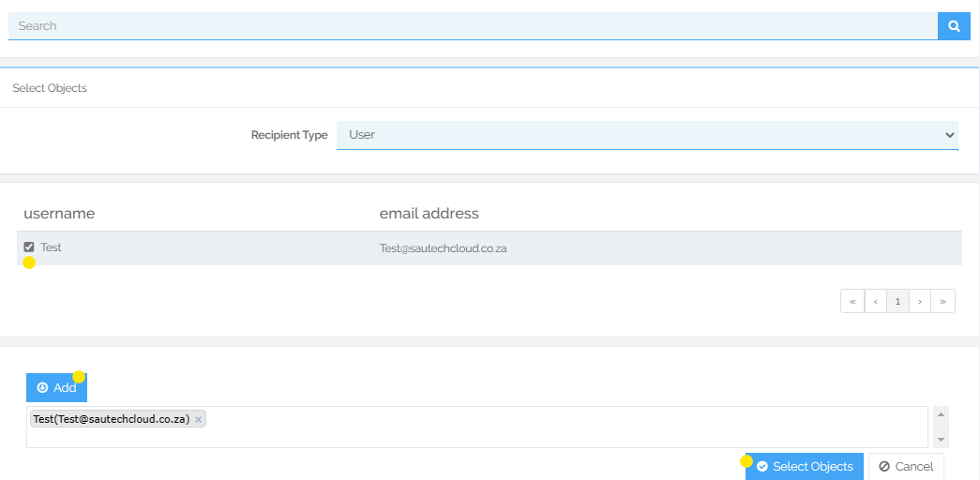

- Once all fields have been completed:

3.4 Click on “Create Distribution List”:

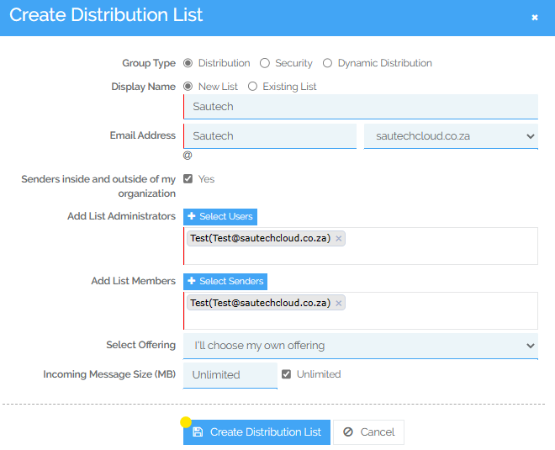

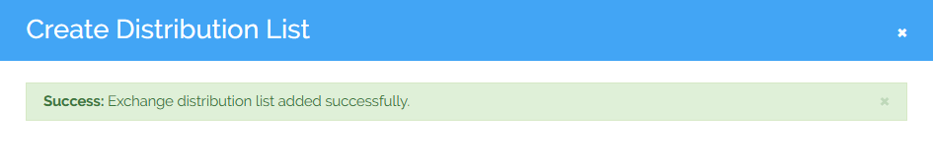
- TO CREATE RESOURCE MAILBOXES:

4.1 Click on “Drop Down” – Select “Recourse Mailbox”:

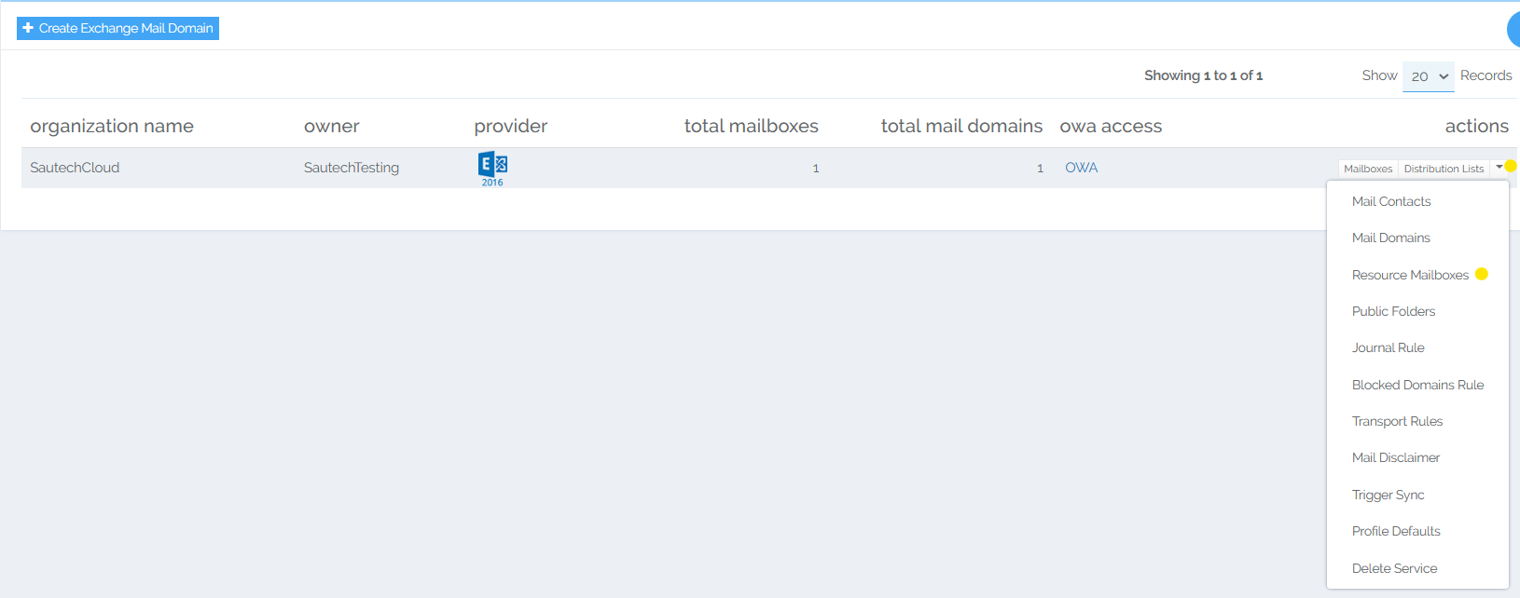
4.2 Click on “Create Recourse Mailbox”:

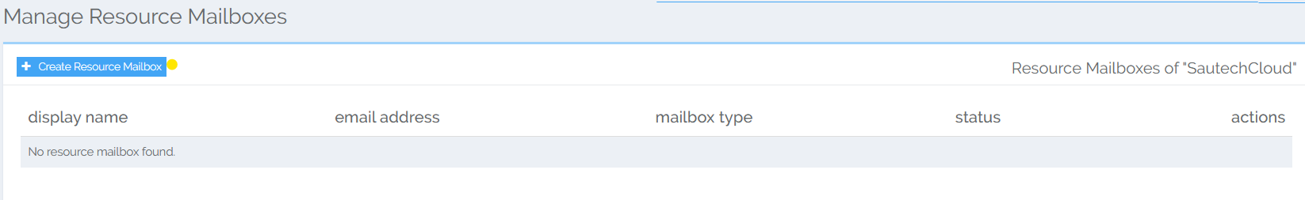

Complete the following Information:
- Resource Name
- Mailbox Size (MB)
- Tic Protocol Boxes (IPAP; POP; OWA/HTTP; MAPI)

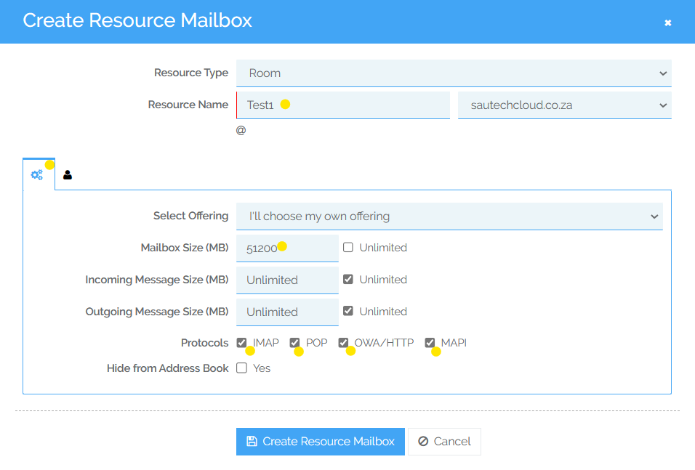

4.3 Select “User Profile”:

Complete the following information:
- Name
- Display Name
- Click on “Create Recourse Mailbox”:

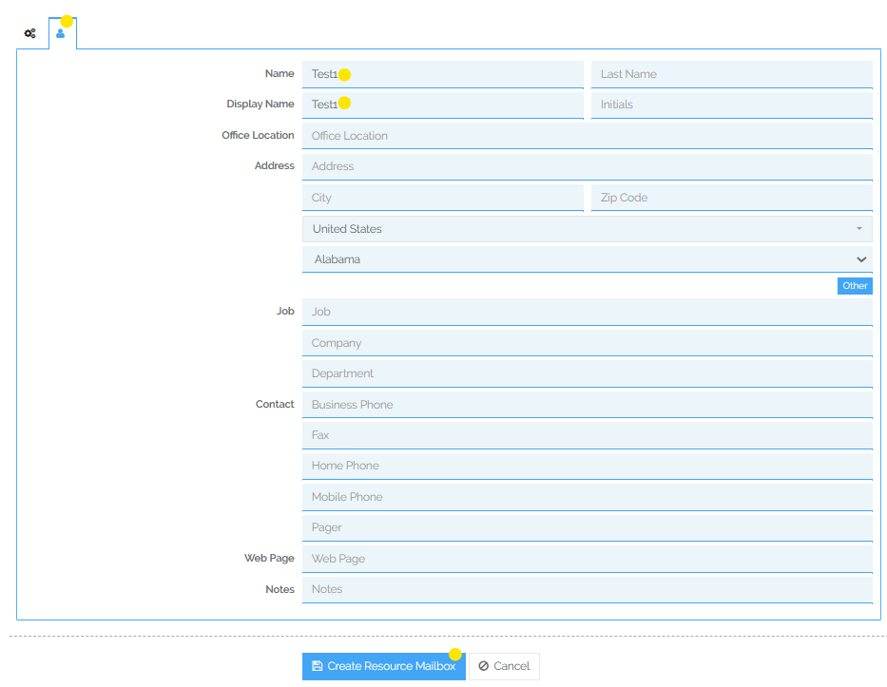
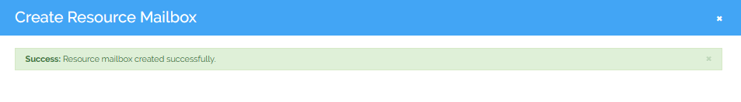
4.4 Once created:

- Send Sautech an email to enable the Recourse Mailbox on the Server.

- TO ADD MORE DOMAINS UNDER THE ORGANAZATION:

5.1 Click on “Drop Down” – Select “Mail Domains”:

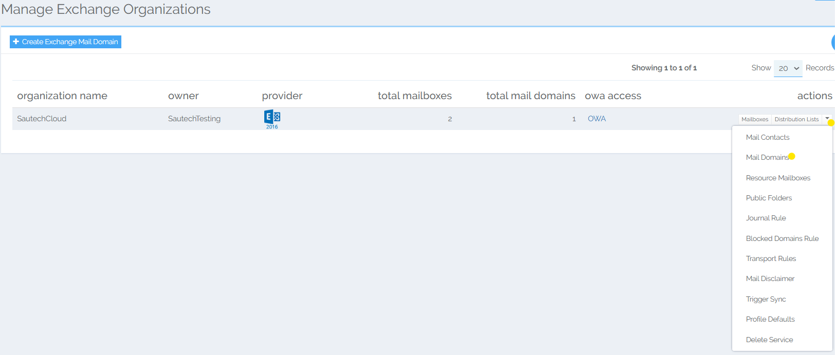
5.2 Click on “Create Exchange Mail Domain”:

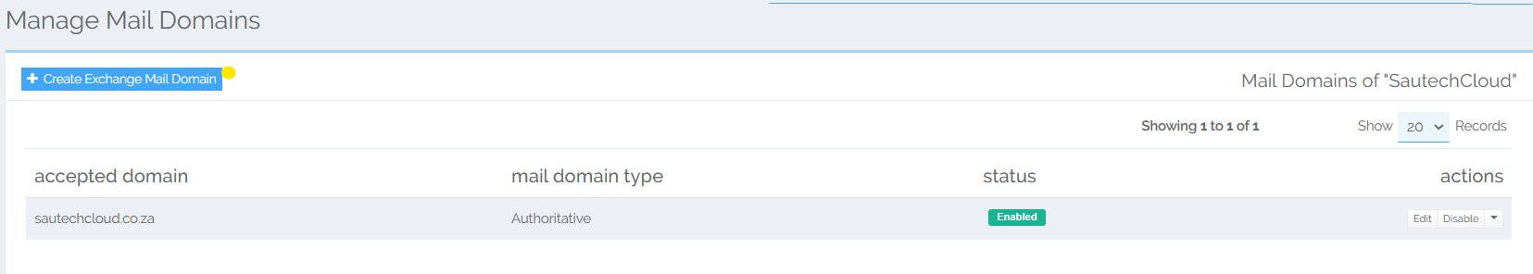

- Type in the Domain that needs to be added

5.2 Select “Create Exchange Mail Domain”:

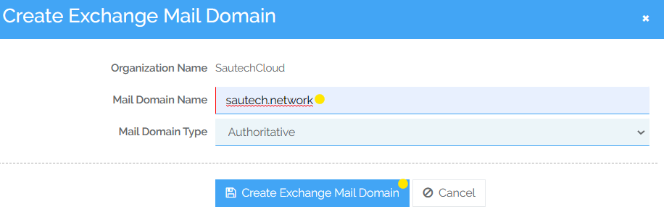
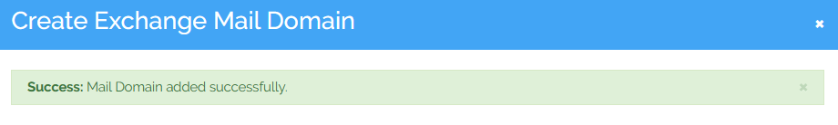

- TO DELETE A Organization:

6.1 Click on “Drop Down” – Select “Delete Service”:

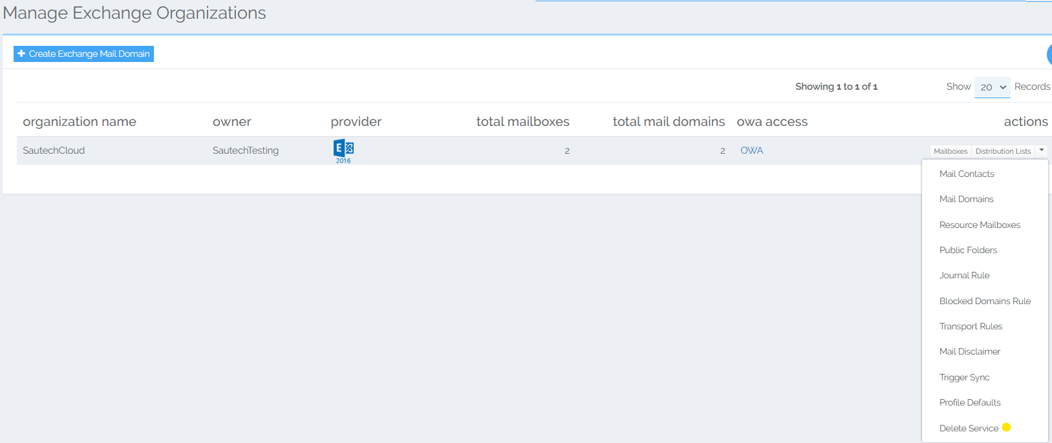

- Should the Domain be Deleted, select “Yes”:

